WEB/APP SERVERS TASK
1.) Install nginx and run nginx on port number 81.
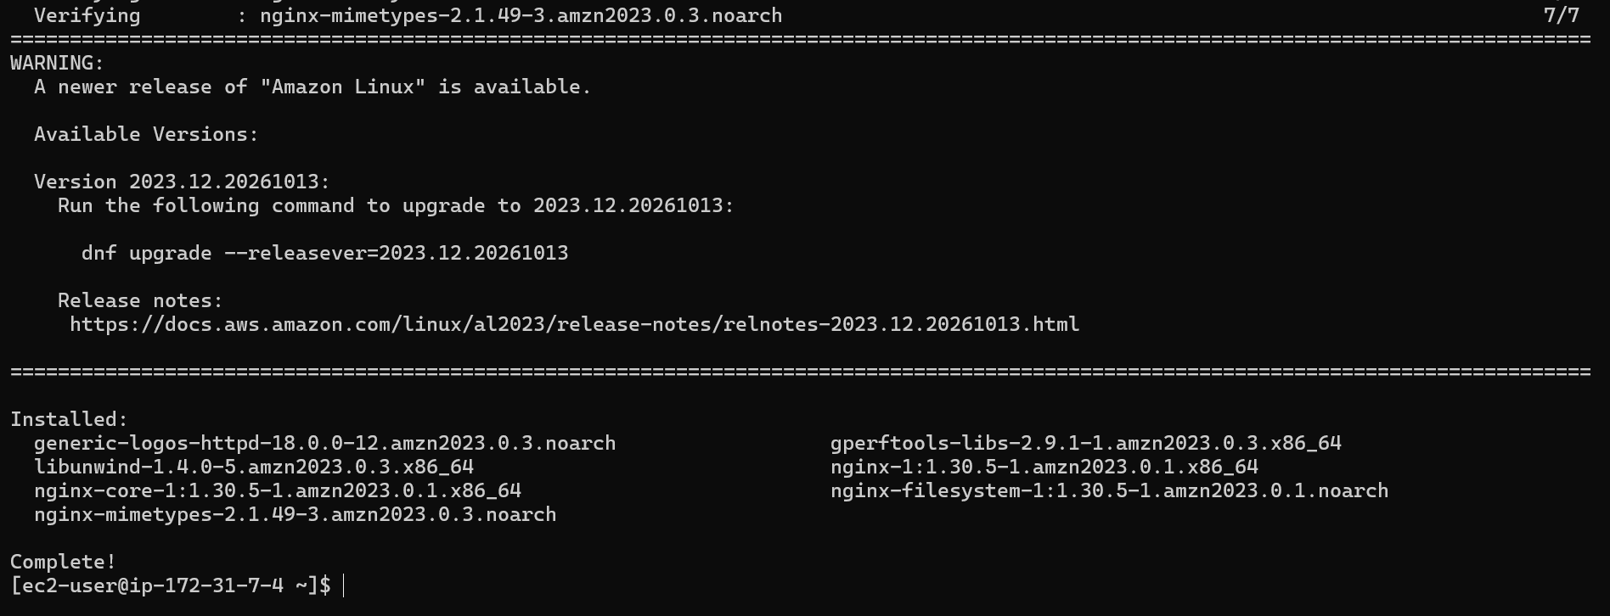
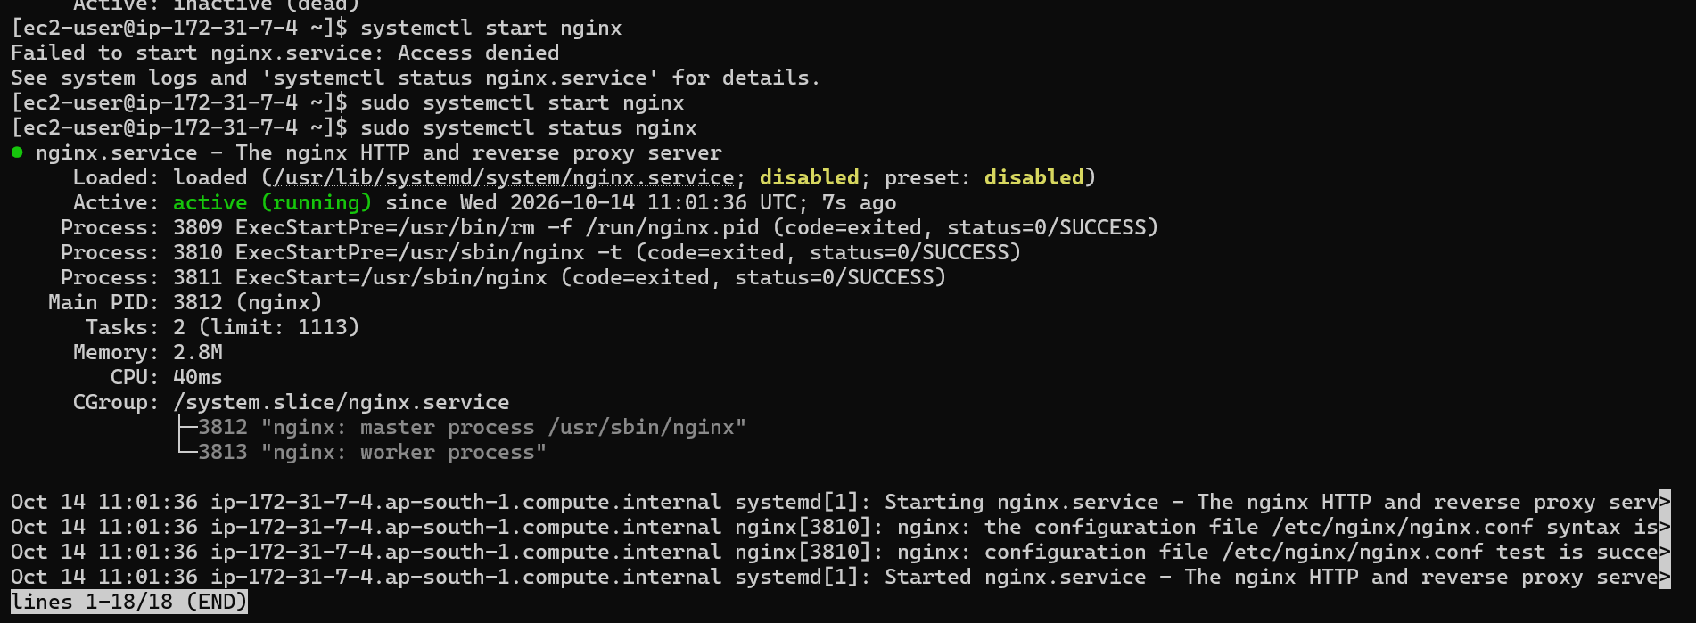
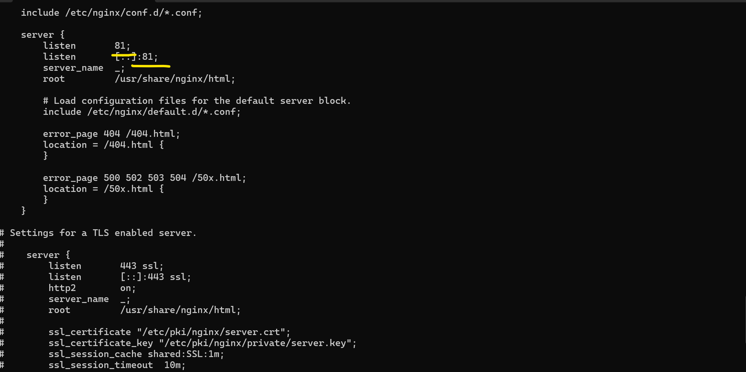
2.) Deploy a sample index.html file on nginx.
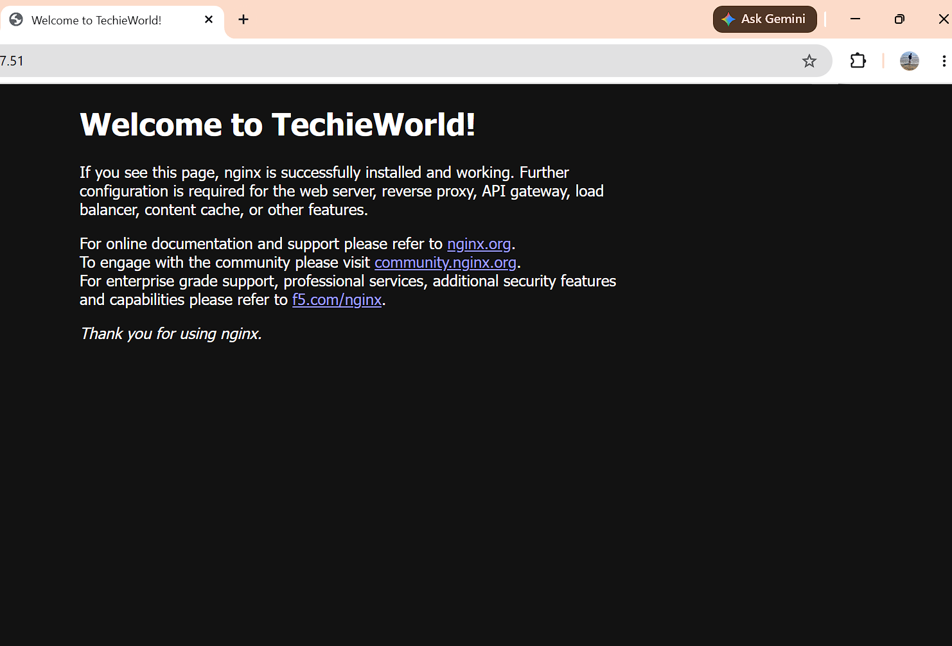
3.) Install Apache and run Apache on port number 81

4.) Deploy a sample index.html file on Apache.

5.) Install Apache tomcat on port number 8082
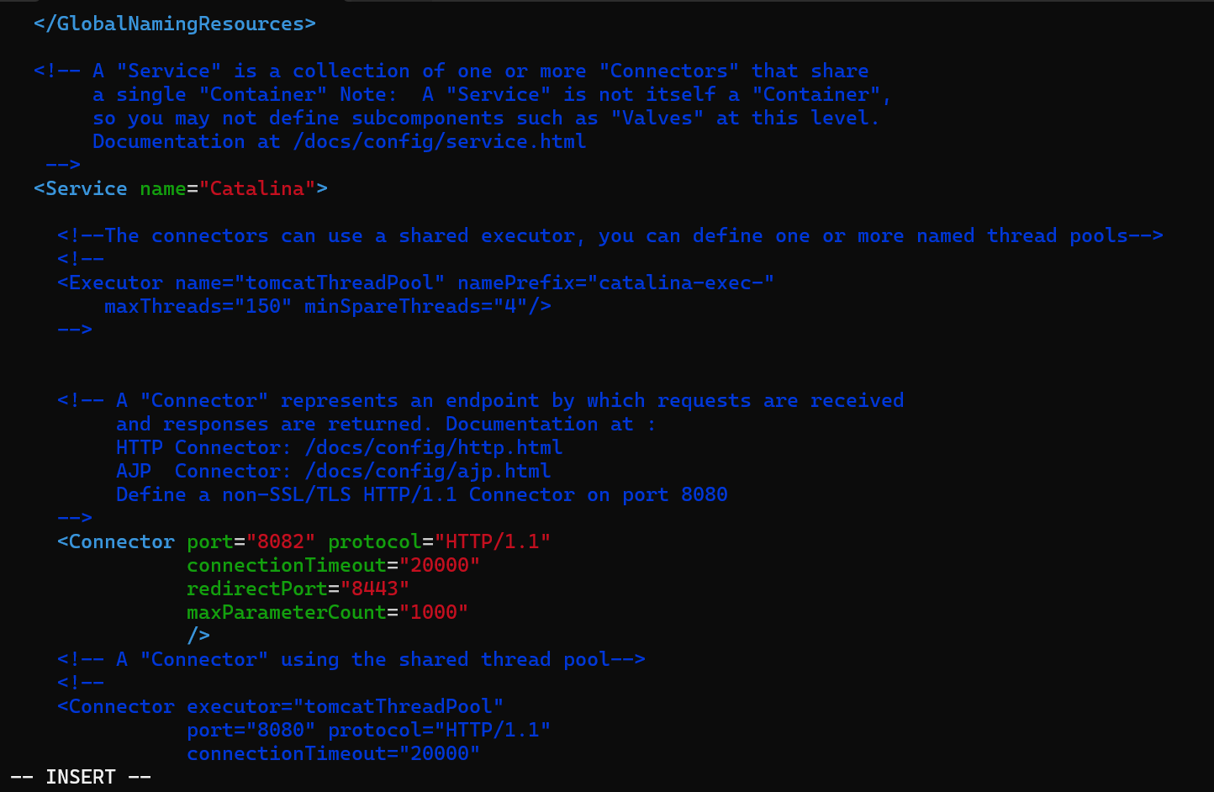
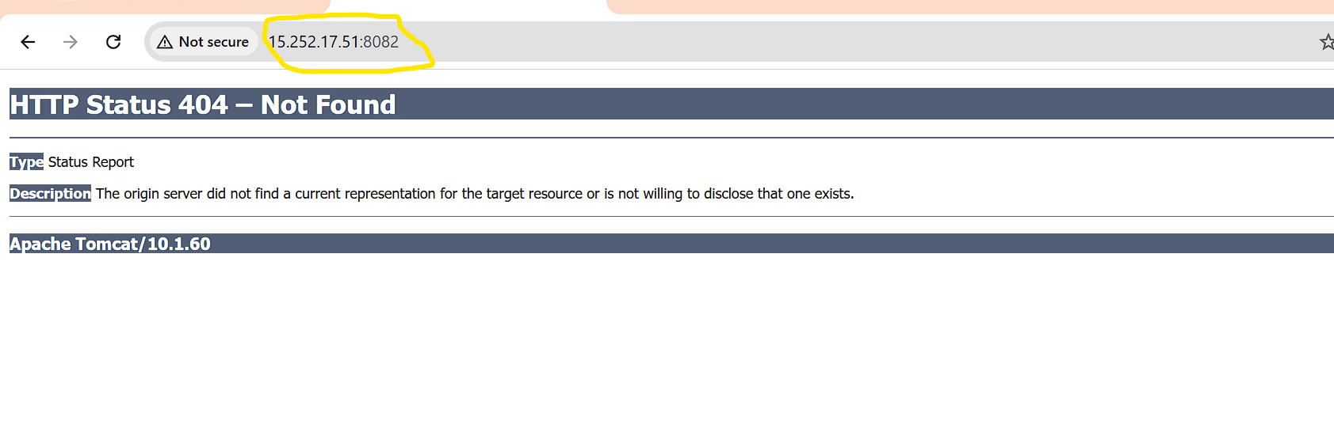
Another way of Installing tomcat
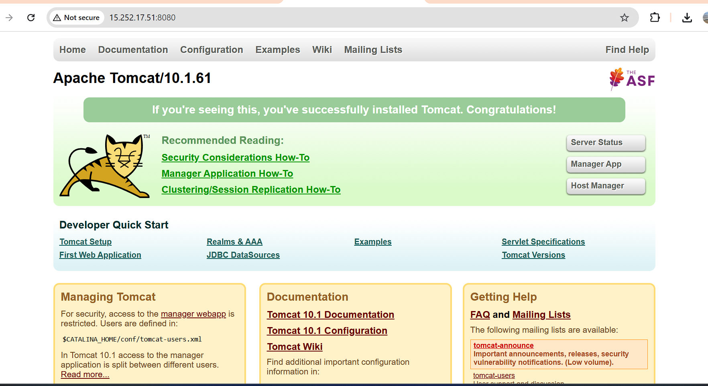

6.) Deploy a sample app on webapps
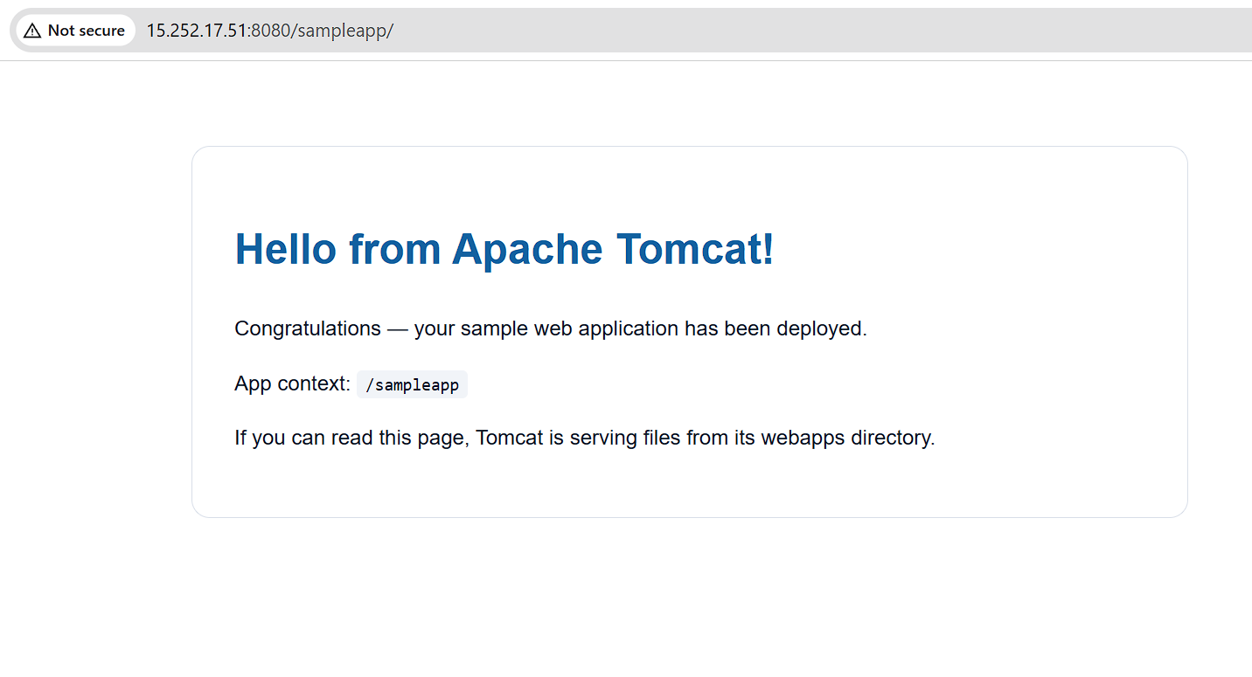
7.) Create a tomcat.service file for tomcat.
-> Just whenever we need to create one service file, need to create it on this following path…
cd /etc/systemd/system/
vi tomcat.service – enter a content (code) into the file. Save and exit.
-> reload the service and chk the status (Active Running)
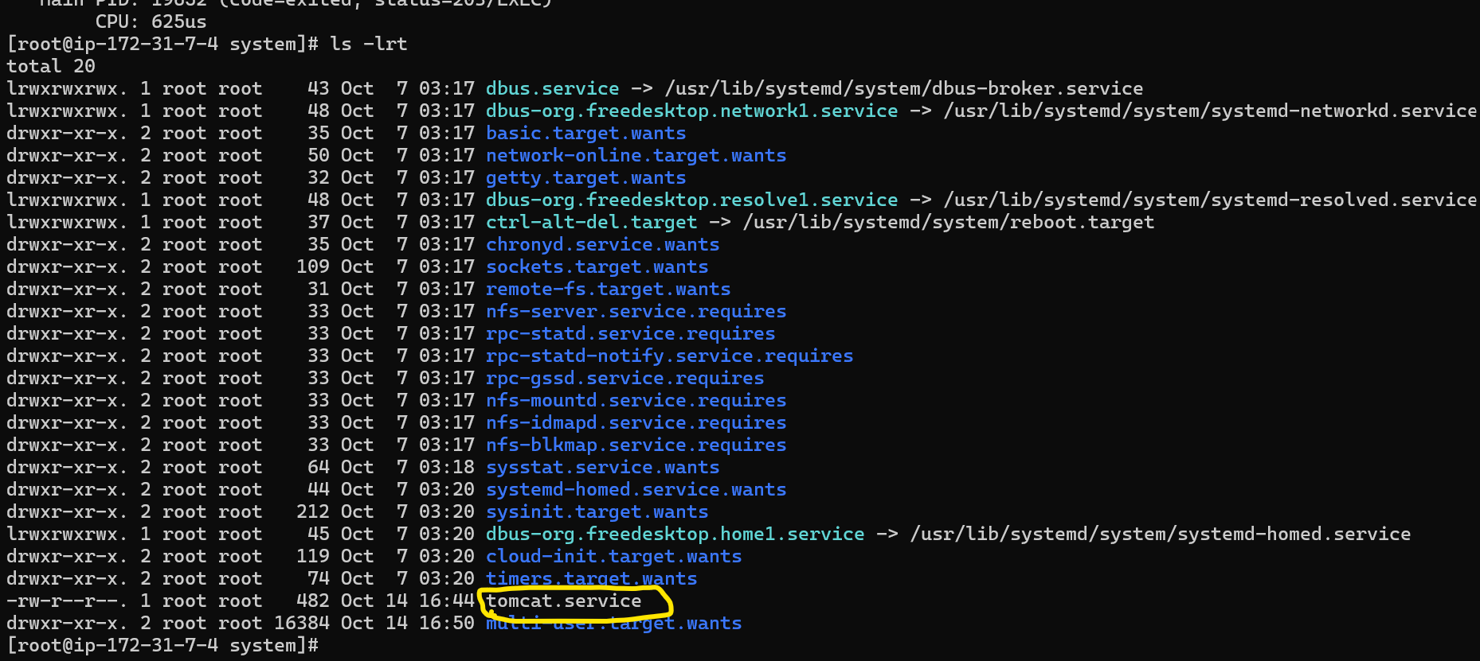

8.) Configure HA Proxy server
step:1 Need to create two instance
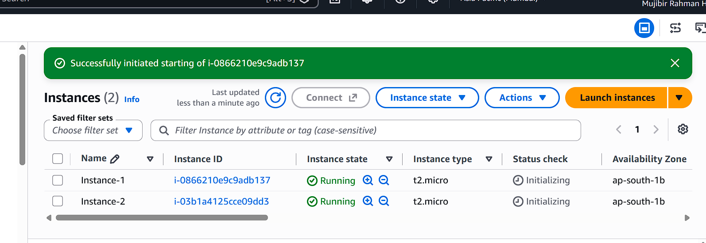
- Step:2 Connecting the instance-1 in windows using following command
ssh -i your-key.pem ec2-user@Pubipaddress of instance-1 instance
step:3 We installed httpd in instance 1 and before that we just checked the update
yum update
yum install httpd -y
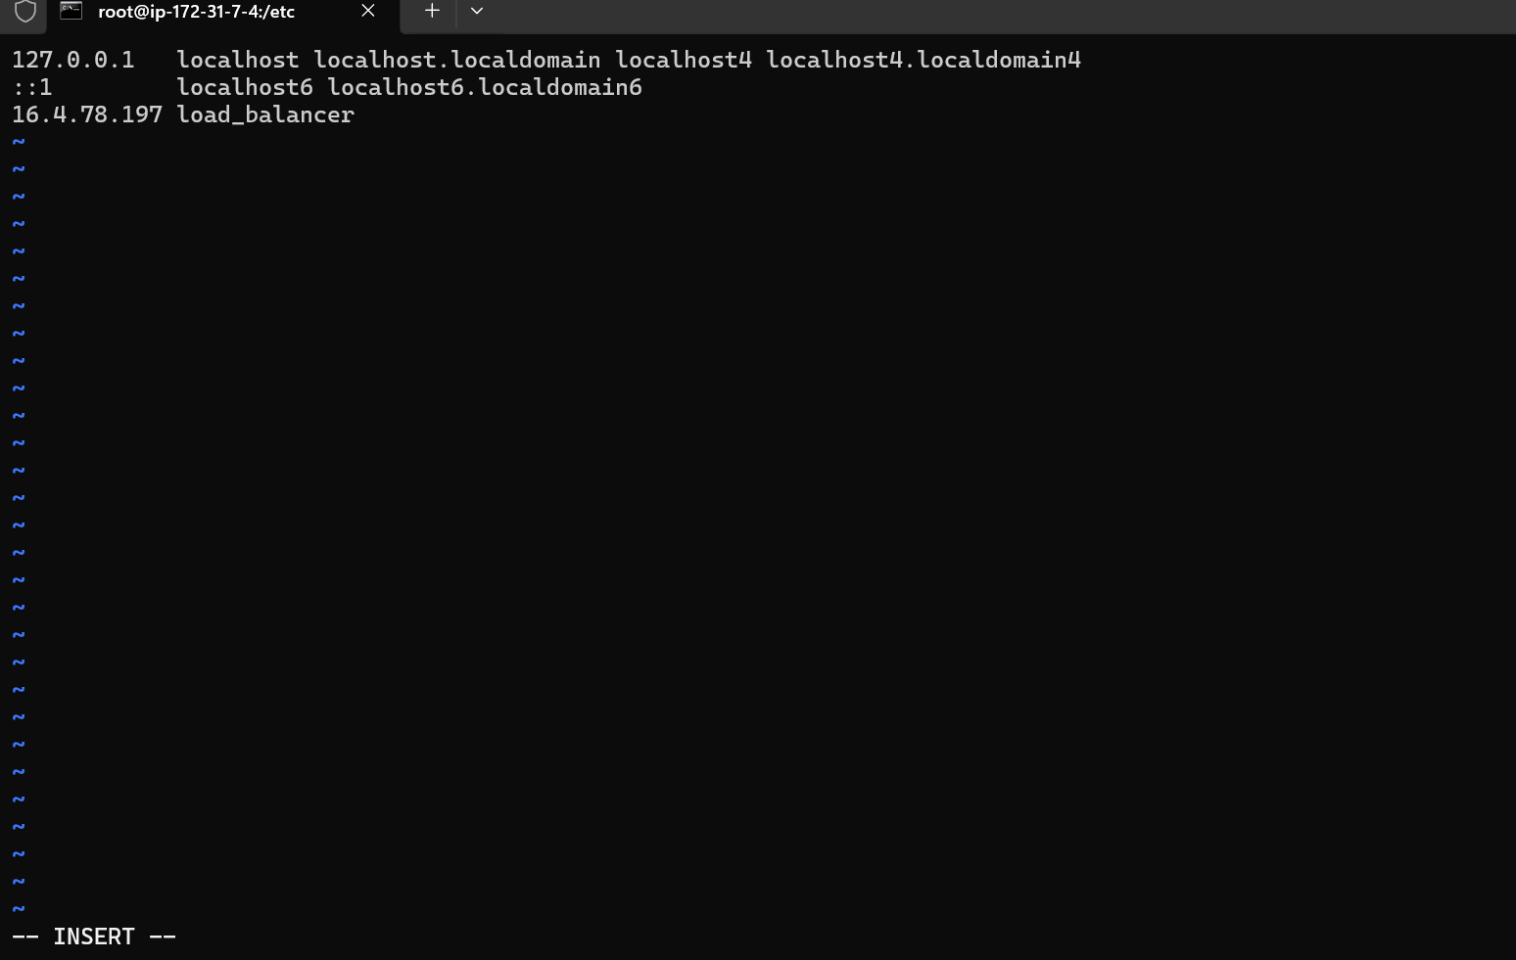
Step : 4 vi /etc/hosts/
add the ha proxy server public Ip (means instance-1 server public Ip)
step:5 ping load_balancer -c 4
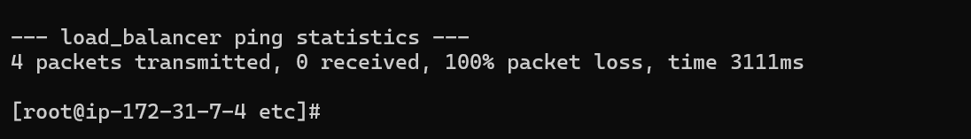
Step :6 We are starting the httpd service and chk the status its running
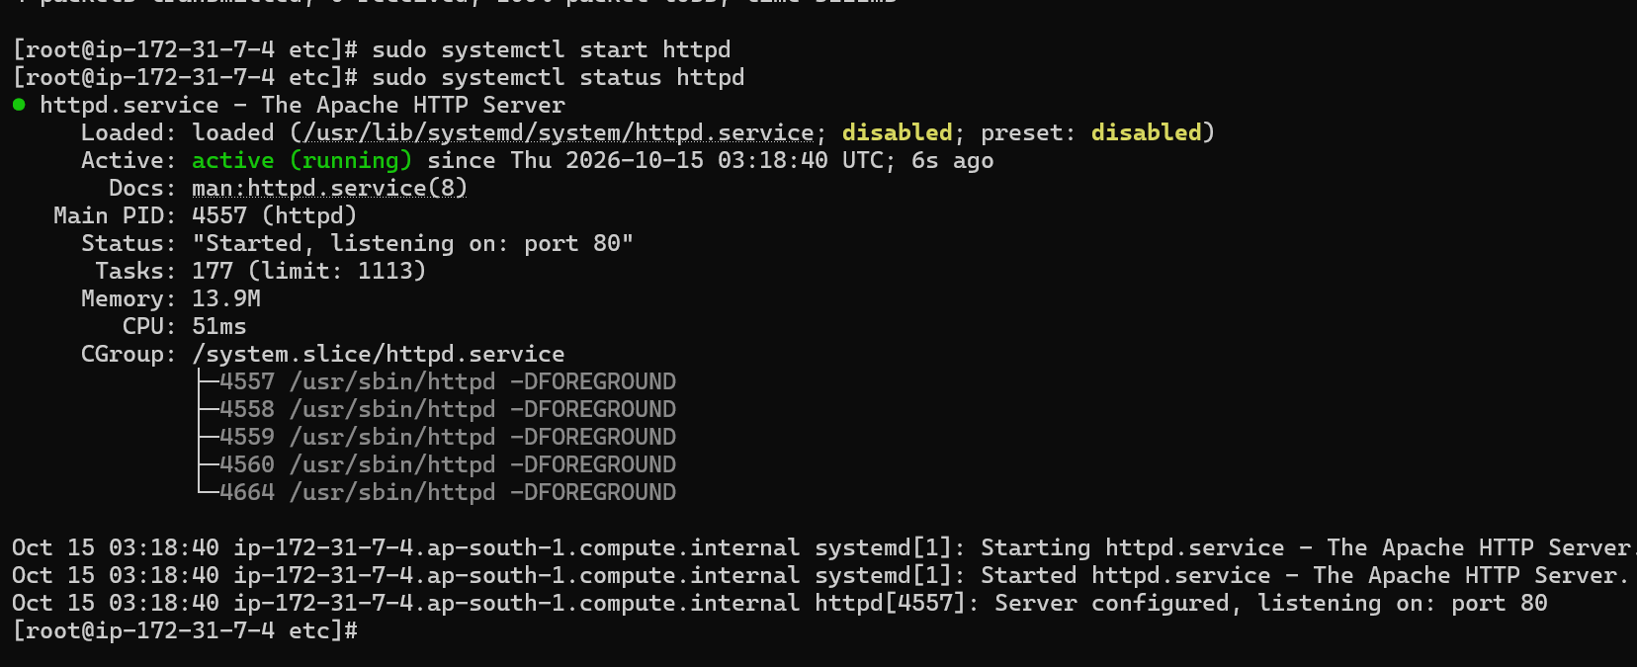

Instance 2 done the steps like instance-1
ha proxy steps:
- Step:1 same like above steps, we need to install ha proxy using below command:
yum install haproxy -y
step:2 vi /etc/hosts/
need to add the above two instance public IP address in this. Save and quit
step:3
Enable , start and chk the status of haproxy
step:4Now I need to able to see the two instance running in same port number. 
